NO.A.61011/1/2019-PHC(KP)/068

**OFFICE OF THE MEDICAL OFFICER PRIMARY HEALTH CENTRE : KAWNPUI**

*Dated Kawnpui the 17th February, 2025*

**ADVERTISEMENT**

Kawnpui PHC athawk tur in IPA hnuaiah Pharmacist (Contract basis – February – May 2025) Post (1) a ruaka. A dil duh tan dil na plain paper ah ziak in office hun chhung in thehluh theih a ni e.

Dil na thehluh hun : Dt. 18-19. 2. 2025

Qualification : B. Pharm

Hlawh : Rs. 15,000/- fixed

Interview hun : Dt. 21.2.2025 11:00 AM ( MO Office)

Interview tur ten documents kimchang ken vek tur a ni e.

Computer thiam duhsak bik an ni ang.

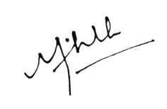

(Dr. MICHELLE LALRINSIAMI)

Medical Officer Kawnpui PHC

NO.A.61011/1/2019-PHC(KP/068 *Dated Kawnpui the 17th February,2025*

Copyto:1)Office file

2) Sr CMO Kolasib Website Management team.

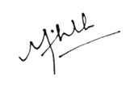

Medical Officer Kawnpui PHC.Kawnpui